CHAPTER I
INTRODUCTION

1.1 Overview
In today's highly competitive job market, both job seekers and recruiters face several challenges during the hiring process. Recruiters often receive hundreds or even thousands of resumes for a single job position, making manual screening time-consuming and inefficient. At the same time, candidates struggle to understand whether their skills and qualifications match the requirements of a particular job role. This gap between candidate profiles and job expectations often results in missed opportunities for both employers and applicants.
With the rapid advancement of Artificial Intelligence (AI) and web technologies, automated systems can now assist in analyzing resumes and matching them with suitable job roles. An AI-based Resume Analyzer and Skill Matcher is a system designed to evaluate resumes, extract relevant information, and compare candidate skills with job requirements. Such systems help automate the resume screening process and provide valuable insights about skill gaps and job suitability.
The proposed project, AI Based Resume Analyzer and Skill Matcher using MERN, is a web-based application developed using the MERN stack, which consists of MongoDB, Express.js, React.js, and Node.js. The system allows users to upload their resumes, after which the AI module analyzes the content to identify key skills, qualifications, and experience. The extracted data is then compared with predefined job requirements to determine how well the resume matches the desired role.
This system not only assists recruiters in shortlisting candidates more efficiently but also helps job seekers understand how well their resumes align with specific job positions. Additionally, the system can recommend improvements or highlight missing skills, allowing candidates to enhance their profiles.
The integration of AI techniques such as Natural Language Processing (NLP) and skill matching algorithms improves the accuracy and effectiveness of resume analysis. By automating the screening process, the system reduces human effort, minimizes bias, and increases the speed of recruitment.
Overall, the AI Based Resume Analyzer and Skill Matcher aims to simplify the recruitment process, improve resume evaluation, and bridge the gap between job seekers and employers through intelligent skill analysis and matching.

1.2 Problem Statement
Recruitment is one of the most important processes in any organization, but it is often time-consuming and inefficient when performed manually. Recruiters must go through a large number of resumes to identify candidates who match the required skills and qualifications for a specific job role. This process requires significant time and effort, and it may also lead to human errors or bias in candidate selection.
Another challenge faced by job seekers is the lack of awareness regarding the skills required for specific job positions. Many candidates submit resumes without knowing whether their skills match the job requirements. As a result, they may face repeated rejections or miss opportunities due to skill gaps.
Traditional resume screening methods are not capable of efficiently handling large volumes of applications. Moreover, manual evaluation does not provide candidates with feedback about their resume quality or suggestions for improvement.
Therefore, there is a need for an intelligent system that can automatically analyze resumes, extract relevant information, compare candidate skills with job requirements, and provide meaningful insights for both recruiters and job seekers.
The proposed AI Based Resume Analyzer and Skill Matcher addresses these issues by using AI techniques to automate resume analysis, evaluate skill compatibility, and provide recommendations for improving candidate profiles.

1.3 Objective of the Project
The main objective of the AI Based Resume Analyzer and Skill Matcher project is to develop an intelligent web-based system that can automatically analyze resumes and match candidate skills with job requirements.
The specific objectives of the project include:
- To design and develop a web application using the MERN stack (MongoDB, Express.js, React.js, and Node.js).
- To allow users to upload resumes in digital format for automated analysis.
- To extract relevant information such as skills, education, and experience from resumes using AI or NLP techniques.
- To compare extracted skills with predefined job requirements and calculate a matching score.
- To provide feedback or recommendations to users about missing skills or improvements needed in their resume.
- To assist recruiters in quickly identifying suitable candidates based on skill compatibility.
- To reduce the time and effort involved in the resume screening process.

1.4 Applications or Scope
The AI Based Resume Analyzer and Skill Matcher system has wide applications in recruitment and career development. The system can be used by companies, recruiters, educational institutions, and job seekers to improve the hiring and job preparation process.
Some major applications and scope of the system include:
- Recruitment Process Automation: Organizations can use the system to automatically screen large numbers of resumes and shortlist suitable candidates based on skill matching.
- Job Recommendation Systems: The system can help job seekers find suitable job roles that match their skills and qualifications.
- Skill Gap Analysis: Candidates can identify missing skills required for their desired job roles and work on improving them.
- Career Guidance for Students: Educational institutions can use the system to guide students in preparing industry-ready resumes and developing relevant skills.
- HR Management Tools: HR departments can integrate the system into their recruitment workflow to speed up the candidate selection process.
- Resume Improvement Platforms: Job seekers can receive suggestions to improve their resumes and increase their chances of selection.
In the future, the system can be extended with additional features such as job portal integration, AI-based resume scoring, personalized job recommendations, and advanced analytics.

1.5 Organization of the Report
This report is organized into several chapters to present the design, development, and implementation of the AI Based Resume Analyzer and Skill Matcher system.
- Chapter 1 – Introduction:
This chapter provides an overview of the project, the problem statement, objectives, applications, and the structure of the report.
- Chapter 2 – Literature Review:
This chapter discusses previous research, existing systems, and technologies related to resume analysis, recruitment automation, and AI-based skill matching.
- Chapter 3 – System Analysis and Design:
This chapter describes the system requirements, architecture, data flow diagrams, and design methodology used in the development of the system.
- Chapter 4 – Implementation:
This chapter explains the technologies used, system modules, database design, and the implementation process of the application.
- Chapter 5 – Results and Discussion:
This chapter presents the system output, testing results, and performance analysis.
- Chapter 6 – Conclusion and Future Work:
This chapter summarizes the project and discusses possible improvements and future enhancements of the system.

CHAPTER II
LITERATURE SURVEY

The rapid growth of digital recruitment platforms has significantly increased the number of job applications submitted for each position. As a result, organizations face challenges in manually screening resumes and identifying suitable candidates efficiently. Researchers and developers have proposed various solutions using Artificial Intelligence (AI), Natural Language Processing (NLP), and Machine Learning (ML) to automate resume analysis and candidate matching. This chapter reviews existing research and technologies related to resume parsing, skill extraction, and automated recruitment systems.
2.1 Resume Screening and Recruitment Automation
Traditional recruitment processes involve manual screening of resumes by human resource (HR) professionals. However, this method is time-consuming and inefficient when dealing with large volumes of applications. Studies show that recruiters often spend a significant portion of their time reviewing resumes and extracting relevant information manually. Automated resume screening systems have been developed to address these challenges by analyzing resumes and ranking candidates based on job requirements.
Recent research highlights that AI-driven recruitment tools can automate resume evaluation and improve candidate selection accuracy. One study proposed an AI-based resume intelligence system that uses Natural Language Processing and AI algorithms to evaluate resumes and generate scoring metrics for candidate selection. The research demonstrates that automated resume evaluation systems can significantly reduce recruiter workload while improving fairness and transparency in the hiring process.
Similarly, modern recruitment technologies focus on automating the extraction of relevant candidate information from resumes and matching it with job descriptions. These systems analyze candidate qualifications, skills, and experience to determine the suitability of applicants for specific roles. Automated recruitment solutions improve hiring efficiency and reduce the chances of human error in the candidate selection process.
2.2 Resume Parsing using Natural Language Processing
Resume parsing is one of the core technologies used in automated recruitment systems. Resume parsing refers to the process of extracting structured information from unstructured resume documents such as PDF, DOCX, or text files. The extracted information typically includes candidate details such as name, education, work experience, skills, certifications, and contact information.
Natural Language Processing (NLP) plays an important role in resume parsing. NLP techniques enable computers to understand and analyze human language in resumes. Through text preprocessing, tokenization, and named entity recognition, NLP models identify relevant information within resume documents.
According to recent studies, AI-based resume parsers use multiple stages to process resumes. First, Optical Character Recognition (OCR) is used to convert scanned documents into text. Then, NLP algorithms analyze the text structure and identify important entities such as job titles, technical skills, and educational qualifications. Finally, machine learning models structure the extracted data into standardized formats that can be easily analyzed by recruitment systems.
Automated resume parsing systems can extract dozens of fields from a resume within seconds with high accuracy. These technologies help recruiters save significant time by eliminating manual data entry and enabling automated candidate analysis.
2.3 Machine Learning and Skill Matching Techniques
Machine Learning algorithms are widely used in resume analysis systems to improve candidate-job matching. These algorithms analyze large datasets of resumes and job descriptions to identify patterns and relationships between candidate skills and job requirements.
In many AI-based recruitment systems, the extracted skills from resumes are compared with job descriptions using similarity algorithms. One common approach involves converting textual data into numerical vectors using techniques such as term frequency-inverse document frequency (TF-IDF) or word embeddings. The similarity between candidate profiles and job descriptions is then calculated using cosine similarity or other mathematical models.
Research on automated resume screening systems shows that NLP-based text mining methods can extract important information such as skills, education, and experience from resumes and rank candidates based on relevance to job descriptions. These systems generate matching scores that help recruiters quickly identify the most suitable candidates.
Advanced systems also use classification algorithms to predict the job domain of candidates based on their resume content. Machine learning models such as Support Vector Machines (SVM), Random Forest, and deep learning models have been used to classify resumes and improve candidate matching accuracy.
2.4 Large Language Models and Intelligent Recruitment Systems
Recent advancements in artificial intelligence have introduced the use of Large Language Models (LLMs) for resume analysis and recruitment automation. LLMs such as transformer-based models can understand contextual relationships in text and provide deeper insights into candidate qualifications.
Researchers have proposed systems that use large language models to extract resume information, evaluate candidate profiles, and provide detailed summaries of applicant qualifications. These systems can analyze resumes more intelligently by understanding the context of skills and experiences rather than relying solely on keyword matching.
In recent research, an explainable AI pipeline was developed to automatically extract information from resumes and match candidates with job descriptions. The system uses document parsing, named entity recognition, and contextual text embeddings to generate similarity scores between resumes and job postings. This approach improves the accuracy of candidate matching while maintaining transparency in decision-making.
Another study proposed a multi-agent framework that uses large language models to automate resume screening. The system includes multiple AI components responsible for extracting resume data, evaluating candidate qualifications, summarizing candidate profiles, and generating scoring metrics. The integration of AI agents allows recruitment systems to perform complex analysis of candidate profiles and improve hiring efficiency.
These advancements demonstrate the growing potential of artificial intelligence in transforming recruitment processes and enabling intelligent hiring systems.
2.5 Existing Resume Analysis Systems
Several commercial and research-based resume analysis systems have been developed to assist recruiters in screening candidates. Many of these systems are integrated with Applicant Tracking Systems (ATS), which store and manage candidate information during the recruitment process.
AI-powered resume analysis tools typically perform tasks such as resume parsing, skill extraction, job matching, candidate ranking, and resume scoring. These systems analyze both resumes and job descriptions to identify the most suitable candidates for specific roles.
Modern AI recruitment software can automatically extract candidate information, convert unstructured resume data into structured formats, and match candidate skills with job requirements. These systems use intelligent algorithms to rank candidates and provide recruiters with a shortlist of the most relevant applicants.
In addition, many resume analysis platforms integrate machine learning models that continuously improve candidate matching based on historical hiring data and recruiter feedback. Such systems help organizations streamline the hiring process and reduce the time required for candidate screening.
2.6 Summary of Literature Review
The literature survey highlights the increasing role of artificial intelligence in modern recruitment systems. Traditional manual screening methods are inefficient when handling large volumes of resumes. AI-based systems provide automated solutions that extract relevant information, analyze candidate skills, and match applicants with job requirements.
Natural Language Processing plays a crucial role in extracting meaningful information from resumes, while machine learning algorithms improve the accuracy of candidate-job matching. Recent advancements in large language models and intelligent recruitment systems further enhance the capabilities of automated resume analysis tools.
Based on the reviewed research, it is evident that AI-based resume analyzers can significantly improve recruitment efficiency by reducing manual effort, minimizing bias, and providing faster candidate evaluation. The proposed AI Based Resume Analyzer and Skill Matcher using MERN builds upon these technologies by integrating modern web development frameworks with AI-based resume analysis techniques to create an efficient and user-friendly recruitment support system.

CHAPTER III
METHODOLOGY

3.1 Background / Overview of Methodology
The recruitment process has traditionally relied on manual screening of resumes by human resource professionals. In large organizations, recruiters receive hundreds or even thousands of resumes for a single job position. Manually reviewing these resumes to identify suitable candidates is a time-consuming and inefficient process. Additionally, manual evaluation may lead to human bias and inconsistencies in candidate selection.
With the advancement of Artificial Intelligence (AI) and Natural Language Processing (NLP), it is now possible to automate the process of resume screening and skill analysis. AI-based systems can analyze textual data from resumes, extract important information such as skills, education, and experience, and compare them with job requirements. This allows recruiters to quickly identify suitable candidates and reduces the overall time required for recruitment.
The proposed project “AI Based Resume Analyzer and Skill Matcher using MERN” is designed to automate resume analysis using intelligent techniques and modern web development technologies. The system allows users to upload resumes in digital format such as PDF or DOCX. The system then processes the resume and extracts relevant information using text processing and skill identification techniques.
The methodology followed in this project includes the following steps:
- Resume upload and data extraction
- Text preprocessing and parsing
- Skill extraction using AI techniques
- Skill matching with predefined job roles
- Score calculation and feedback generation
The system is developed using the MERN stack, which consists of MongoDB for database management, Express.js and Node.js for backend services, and React.js for the frontend interface. This architecture allows the system to be scalable, efficient, and easy to maintain.
By combining AI-based analysis with modern web technologies, the system aims to provide an efficient solution for automated resume screening and candidate evaluation.

3.2 Project Platforms used in Project
The proposed system is developed using modern web development technologies and tools. The main platform used for this project is the MERN stack, which is widely used for building full-stack web applications.
3.2.1 MongoDB
MongoDB is a NoSQL database used for storing application data. It stores data in JSON-like documents, which makes it flexible and suitable for handling dynamic data structures. In this project, MongoDB is used to store user information, uploaded resumes, extracted skills, job descriptions, and matching results.
The advantages of using MongoDB include:
- Flexible schema design
- High performance and scalability
- Easy integration with Node.js
- Efficient storage of structured and unstructured data
3.2.2 Express.js
Express.js is a backend web application framework for Node.js. It is used to build RESTful APIs and handle server-side operations. In this project, Express.js manages user requests such as resume uploads, data processing, and communication with the database.
Key features of Express.js include:
- Lightweight and fast backend framework
- Easy routing and middleware integration
- Simplified API development
3.2.3 React.js
React.js is a JavaScript library used for building interactive user interfaces. It allows developers to create reusable components and manage application state efficiently. In this project, React.js is used to develop the frontend interface where users can upload resumes, view analysis results, and receive feedback.
Benefits of using React.js include:
- Fast rendering using virtual DOM
- Component-based architecture
- Improved user experience
3.2.4 Node.js
Node.js is a server-side JavaScript runtime environment that allows developers to run JavaScript code outside the browser. In this project, Node.js handles backend processing such as resume parsing, skill extraction, and communication between the frontend and database.
Advantages of Node.js include:
- High performance
- Event-driven architecture
- Scalability for large applications
3.2.5 Additional Tools and Technologies
Other tools used in the project include:
- Natural Language Processing (NLP) for text analysis
- PDF parser libraries for extracting text from resumes
- GitHub for version control
- Visual Studio Code for development
- Postman for API testing
These tools help in developing, testing, and maintaining the application efficiently.

3.3 Proposed Methodology
The proposed methodology for the AI Based Resume Analyzer and Skill Matcher system involves multiple steps that work together to analyze resumes and match candidate skills with job requirements.
The overall workflow of the system is shown below.
Step 1: Resume Upload
The process begins when a user uploads their resume through the web application interface. The system accepts resumes in common formats such as PDF or DOCX.
Step 2: Resume Parsing
After the resume is uploaded, the system extracts the textual content from the document. Resume parsing tools convert the file into readable text format so that it can be analyzed by the system.
Step 3: Text Preprocessing
The extracted text is processed to remove unnecessary information and prepare it for analysis. Text preprocessing steps include:
- Removing special characters
- Converting text to lowercase
- Tokenization
- Stop-word removal
These steps improve the accuracy of skill extraction.
Step 4: Skill Extraction
In this stage, the system identifies important keywords related to skills, technologies, and qualifications. A predefined skill dataset is used to detect relevant technical and professional skills present in the resume.
For example, skills such as:
- Java
- Python
- React
- Node.js
- Machine Learning
are extracted from the resume.
Step 5: Skill Matching
The extracted skills are compared with the skills required for specific job roles stored in the database. The system calculates a matching score based on the similarity between candidate skills and job requirements.
Step 6: Score Generation
The system generates a skill matching score that represents how well the candidate's resume matches the job requirements. This score helps recruiters quickly evaluate candidate suitability.
Step 7: Feedback and Recommendations
The system also provides feedback to users by identifying missing skills required for a particular job role. This helps candidates improve their resumes and enhance their career opportunities.

3.4 Project Modules
The proposed system is divided into several modules to ensure efficient functionality and better system organization.
3.4.1 User Authentication Module
This module allows users to register and log in to the system. User authentication ensures that only authorized users can access the application.
Features include:
- User registration
- Login authentication
- Secure user sessions
3.4.2 Resume Upload Module
This module allows users to upload their resumes through the web interface. The uploaded resume is stored in the system for further processing.
Features include:
- File upload functionality
- Resume storage
- File format validation
3.4.3 Resume Parsing Module
This module extracts text from uploaded resumes and converts them into a readable format. It prepares the data for further analysis.
Features include:
- PDF and document parsing
- Text extraction
- Data cleaning
3.4.4 Skill Extraction Module
This module analyzes the extracted text and identifies relevant skills mentioned in the resume.
Features include:
- Keyword identification
- Skill recognition
- Skill classification
3.4.5 Skill Matching Module
This module compares the extracted skills with job role requirements stored in the database.
Features include:
- Job role comparison
- Skill matching algorithm
- Matching score calculation
3.4.6 Result and Feedback Module
This module displays the analysis results to the user. It shows the skill match percentage and suggests missing skills.
Features include:
- Resume score display
- Skill gap analysis
- Improvement recommendations

3.5 Diagrams (ER, Use Case, DFD, etc.)
To better understand the working of the system, several diagrams are used to represent the system architecture and data flow.
3.5.1 Use Case Diagram
The Use Case Diagram represents the interaction between users and the system.
Actors involved:
- User (Job Seeker)
- Admin
User actions include:
- Register/Login
- Upload Resume
- View Resume Analysis
- View Skill Matching Result
Admin actions include:
- Manage job roles
- Manage skill database
Diagram :
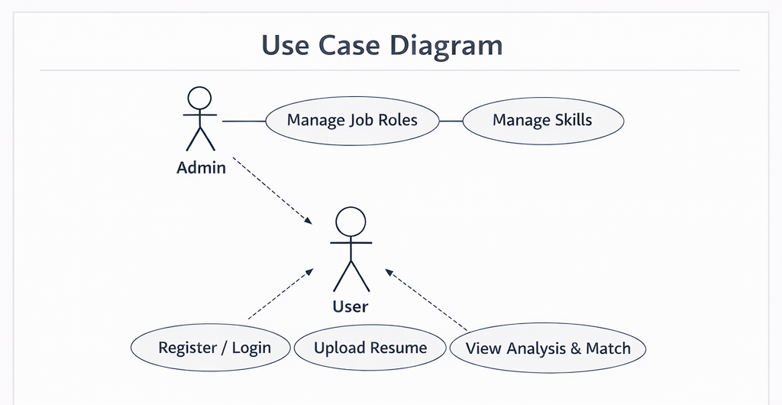

3.5.2 Data Flow Diagram (DFD)
The Data Flow Diagram illustrates how data flows within the system.
Level 0 DFD includes:
Input:
- Resume upload
Processes:
- Resume parsing
- Skill extraction
- Skill matching
Output:
- Resume score
- Skill recommendations

Diagram :
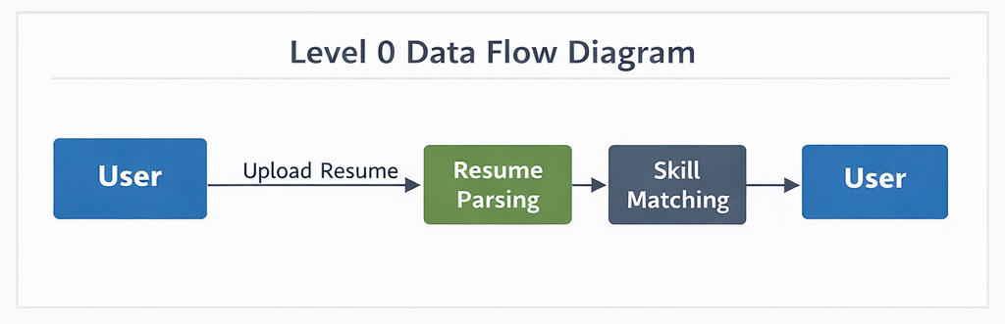

Level 1 DFD includes detailed processes such as:
- User authentication
- Resume processing
- Database storage
- Result generation
Diagram :
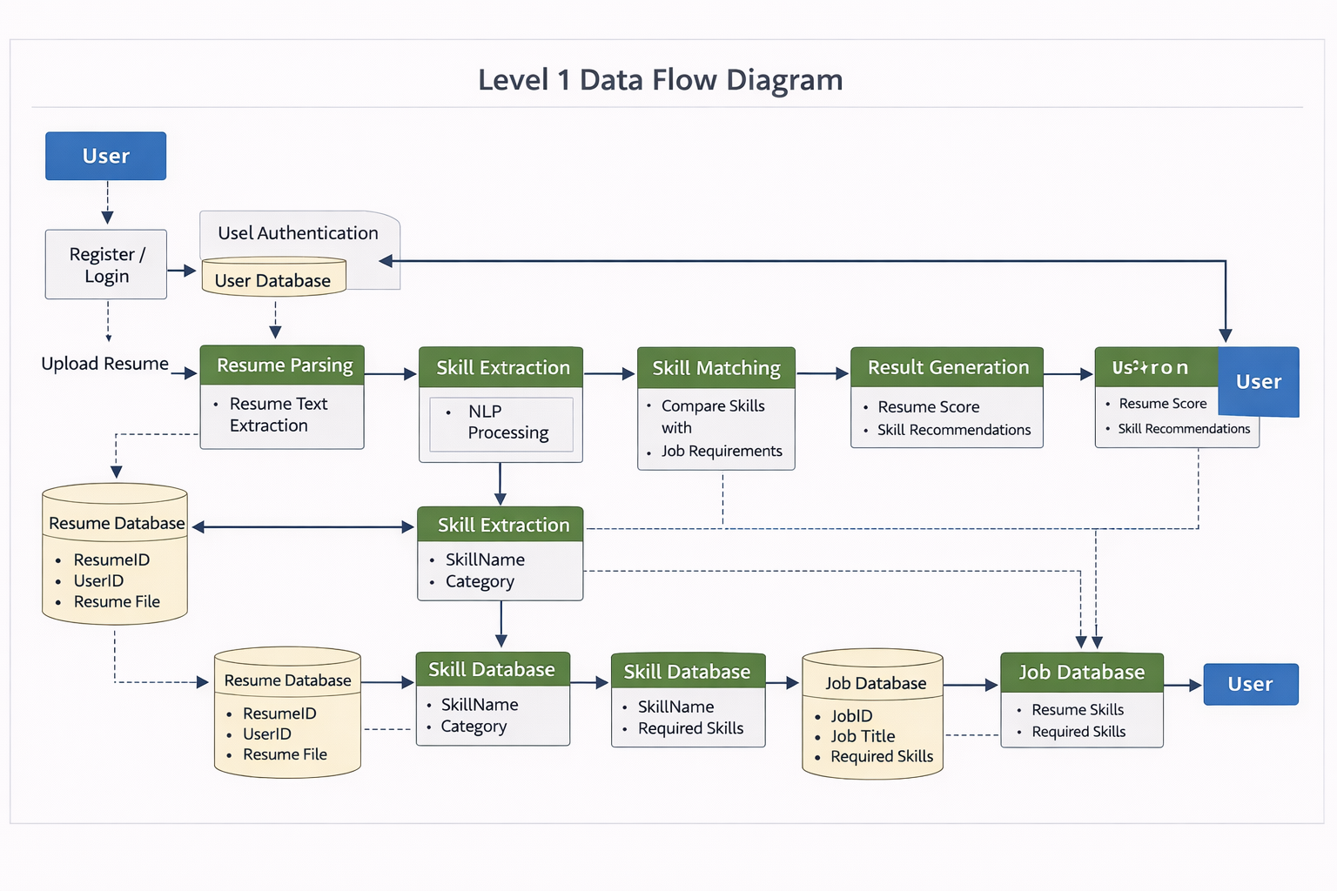

3.5.3 Entity Relationship (ER) Diagram
The ER diagram represents the relationship between different entities in the database.
Main entities include:
User Entity
- User ID
- Name
- Email
- Password
Resume Entity
- Resume ID
- User ID
- Resume File
- Extracted Skills
Job Role Entity
- Job ID
- Job Title
- Required Skills
Match Result Entity
- Match ID
- Resume ID
- Job ID
- Match Score
Diagram :
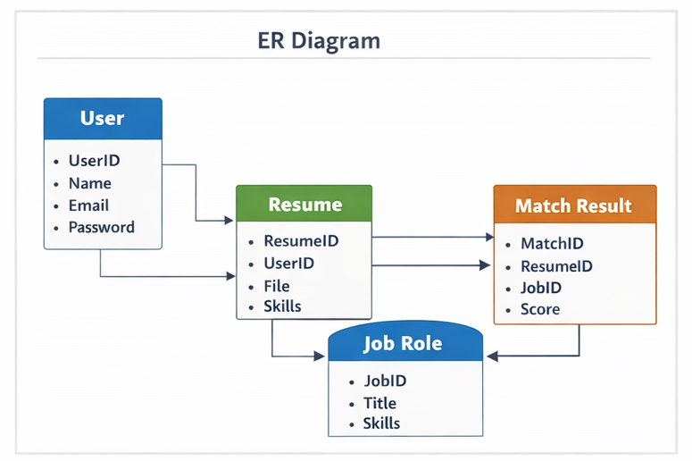
CHAPTER IV
SYSTEM REQUIREMENTS

The successful development and execution of the AI Based Resume Analyzer and Skill Matcher using MERN system require specific software and hardware resources. These requirements ensure that the system runs smoothly, performs resume analysis efficiently, and provides accurate results to users.
System requirements are divided into two main categories: software requirements and hardware requirements.

4.1 Software Requirements
Software requirements include all the software tools, frameworks, libraries, and operating systems required for the development and deployment of the proposed system. The project is primarily developed using the MERN stack, along with additional tools for development, testing, and version control.
4.1.1 Operating System
The system can be developed and executed on modern operating systems such as:
- Windows 10 / Windows 11
- Linux (Ubuntu or other distributions)
- macOS
For the development of this project, Windows 10 or above is recommended due to its compatibility with most development tools and software environments.
4.1.2 Programming Languages
The primary programming languages used in the project include:
JavaScript
JavaScript is used for both frontend and backend development. It plays an important role in implementing the MERN stack architecture.
HTML (HyperText Markup Language)
HTML is used for structuring the web pages and creating the basic layout of the user interface.
CSS (Cascading Style Sheets)
CSS is used to style the web pages and improve the visual appearance of the application.
4.1.3 MERN Stack Technologies
The project is built using the MERN stack, which includes the following technologies:
MongoDB
MongoDB is a NoSQL database used to store application data such as user details, resumes, extracted skills, job roles, and matching results. It stores data in flexible JSON-like documents, making it suitable for handling dynamic data structures.
Express.js
Express.js is a backend framework for Node.js used to build RESTful APIs and manage server-side operations. It handles user requests, processes resume data, and communicates with the database.
React.js
React.js is used for building the frontend user interface. It provides a dynamic and interactive environment for users to upload resumes, view analysis results, and interact with the application.
Node.js
Node.js is a runtime environment that allows JavaScript to run on the server side. It is responsible for handling backend operations such as resume parsing, skill extraction, and database communication.
4.1.4 Development Tools
Several development tools are used to design, implement, and test the application.
Visual Studio Code (VS Code)
VS Code is used as the primary code editor for writing and managing the project code.
Postman
Postman is used for testing APIs developed using Express.js and Node.js.
Git and GitHub
Git is used for version control, while GitHub is used to store and manage the project repository online.
Node Package Manager (NPM)
NPM is used to install required libraries and dependencies such as React libraries, Express modules, and parsing tools.
4.1.5 Libraries and APIs
Additional libraries and APIs are used to implement specific functionalities within the system.
Examples include:
- PDF Parser Libraries – Used to extract text from uploaded resumes.
- Natural Language Processing Libraries – Used to identify and extract skills from resume text.
- Axios or Fetch API – Used to communicate between frontend and backend.
These libraries improve the functionality of the system and simplify development.

4.2 Hardware Requirements
Hardware requirements refer to the physical components required to develop, test, and run the application. Since the system is a web-based application, it does not require highly specialized hardware. However, a basic computer system with moderate performance is necessary to ensure smooth development and execution.
4.2.1 Processor
A modern processor is required to handle development tools and application execution efficiently.
Recommended processors include:
- Intel Core i3 or higher
- AMD Ryzen 3 or higher
These processors provide sufficient performance for running development environments, databases, and web servers.
4.2.2 Memory (RAM)
Memory plays an important role in running multiple development tools simultaneously.
Recommended RAM:
- Minimum: 4 GB RAM
- Recommended: 8 GB RAM or higher
Higher RAM capacity improves system performance and allows smoother execution of Node.js servers, databases, and frontend applications.
4.2.3 Storage
Adequate storage space is required for installing development tools, storing project files, and maintaining the database.
Recommended storage:
- Minimum: 100 GB Hard Disk Space
- Preferred: Solid State Drive (SSD) for faster performance.
SSD storage improves system speed and reduces application loading time.
4.2.4 Internet Connectivity
A stable internet connection is required for:
- Installing libraries and packages
- Accessing online repositories such as GitHub
- Deploying the application
- Testing web-based features
4.2.5 Display and Input Devices
Basic input and output devices are required for development and interaction with the system.
Required devices include:
- Monitor (minimum resolution 1366×768)
- Keyboard
- Mouse or touchpad
These devices allow developers and users to interact with the application effectively.

CHAPTER V
EXPECTED OUTCOMES (with GUI)

The primary objective of the AI Based Resume Analyzer and Skill Matcher using MERN system is to automate resume evaluation and provide meaningful insights about candidate skills. The system leverages artificial intelligence and Natural Language Processing (NLP) to extract skills from resumes and match them with job requirements. This chapter describes the expected outcomes of the project and presents a GUI-based overview of system functionalities.

5.1 Expected Functional Outcomes
The project aims to provide several functional outcomes that enhance both recruiter and candidate experiences:
5.1.1 Efficient Resume Screening
One of the key outcomes of this project is the ability to automatically analyze resumes uploaded by candidates. The system parses resumes in formats such as PDF and DOCX and extracts structured information including:
- Personal details (name, contact information)
- Educational qualifications
- Work experience
- Skills and certifications
By automating the resume screening process, recruiters can save a significant amount of time compared to manual evaluation.

5.1.2 Skill Extraction and Categorization
The system identifies relevant skills mentioned in resumes using NLP techniques. Skills are categorized based on:
- Technical skills (e.g., Java, Python, Node.js, React.js)
- Soft skills (e.g., communication, teamwork)
- Domain-specific skills (e.g., Machine Learning, Data Analysis)
This categorization helps both recruiters and candidates understand the skill profile of each applicant more clearly.

5.1.3 Skill Matching with Job Requirements
After extracting skills, the system matches them against predefined job requirements stored in the database. The expected outcomes of this module include:
- Matching Score: A numerical score representing how closely the candidate’s skills match the job requirements (e.g., 85% match).
- Skill Gap Analysis: Identification of missing or underdeveloped skills relevant to the job role.
- Recommendations: Suggestions to improve resumes or acquire additional skills to increase suitability for the desired role.
This outcome is particularly beneficial for candidates to optimize their resumes and for recruiters to quickly shortlist qualified applicants.

5.1.4 Interactive Dashboard for Users
The system provides a GUI-based dashboard that presents the results in a user-friendly manner. Key expected outcomes for the dashboard include:
- Resume Upload Section: A simple interface where users can select and upload resumes.
- Resume Analysis Section: Display of extracted information including personal details, skills, experience, and education.
- Matching Score Visualization: Graphical representation of how well the candidate’s skills align with job requirements.
- Skill Gap Highlighting: Missing skills are highlighted for easy identification.
- Exportable Reports: Option to download or print analysis results in PDF format.
This GUI ensures ease of use and improves overall user engagement.

5.2 Expected Non-Functional Outcomes
In addition to functional outcomes, the project also aims to achieve several non-functional benefits:
- Time Efficiency: Automates resume screening to reduce recruitment time.
- Accuracy: Minimizes human error in evaluating candidate profiles.
- Scalability: Handles a large number of resumes without performance degradation.
- User-Friendly Interface: Simplifies interaction for both recruiters and job seekers.
- Feedback Mechanism: Provides actionable insights for candidates to improve their resumes.

5.3 Graphical User Interface (GUI) Overview
The GUI is designed to provide intuitive access to all functionalities of the system. Below are the key screens and their expected outcomes:
5.3.1 Login and Registration Screen
- Users can register using email and password.
- Existing users can log in securely.
- Session management ensures that only authenticated users access the system.
Expected Outcome: Secure access and personalized user experience.

5.3.2 Resume Upload Screen
- Users can select and upload resumes in PDF or DOCX formats.
- A progress bar indicates upload status.
- Validation ensures the correct file format is uploaded.
Expected Outcome: Smooth resume submission process without technical errors.

5.3.3 Resume Analysis Screen
- Extracted information is displayed in a structured table format.
- Skills, education, and experience sections are clearly separated.
- Users can verify the accuracy of the extracted information.
Expected Outcome: Clear, organized display of resume content for easy comprehension.

5.3.4 Skill Matching Screen
- Matching score is displayed prominently, along with a color-coded indicator:
  - Green: High match
  - Yellow: Moderate match
  - Red: Low match
- Missing skills are listed separately for easy identification.
- Users receive recommendations to improve their resumes.
Expected Outcome: Insightful evaluation that guides candidates to improve job fit.

5.3.5 Dashboard and Reports Screen
- Graphs and charts visualize skill distribution, experience, and match percentage.
- Exportable reports allow sharing or printing resume analysis results.
- Recruiters can view multiple candidate profiles in one dashboard.
Expected Outcome: Enhanced decision-making for recruiters and candidates through interactive visualization.

5.4 Summary of Expected Outcomes
The AI Based Resume Analyzer and Skill Matcher system is expected to achieve the following:
Outcome | Description
Automated Resume Screening | Extracts and structures resume content quickly.
Skill Extraction | Identifies and categorizes relevant technical, soft, and domain-specific skills.
Skill Matching | Matches candidate skills against job requirements and generates a matching score.
Skill Gap Analysis | Highlights missing skills and suggests improvements.
GUI Dashboard | Provides an intuitive interface with resume upload, analysis, and results visualization.
Report Generation | Allows exporting resume evaluation and skill matching results.
Diagram :

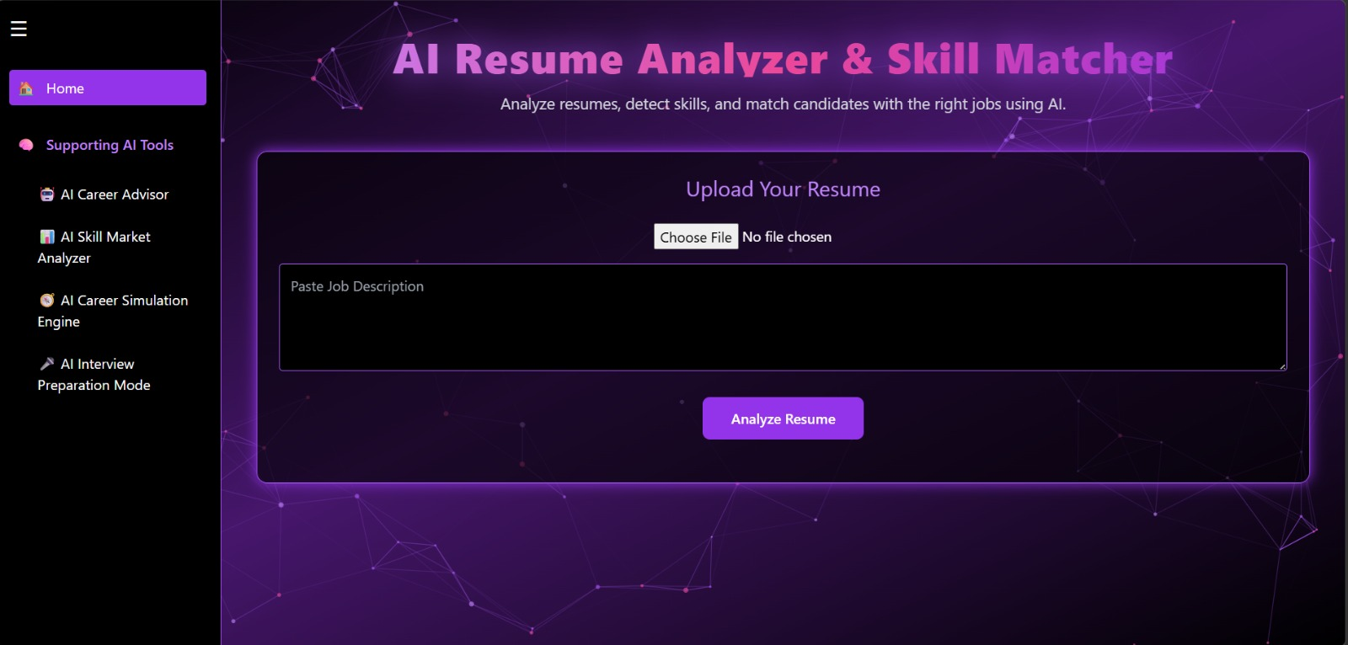
CHAPTER VI
CONCLUSION & FUTURE SCOPE

6.1 Conclusion
The AI Based Resume Analyzer and Skill Matcher using MERN project successfully demonstrates how artificial intelligence and modern web technologies can be combined to automate and improve the recruitment process. By leveraging the MERN stack (MongoDB, Express.js, React.js, and Node.js) along with AI and Natural Language Processing (NLP) techniques, the system provides an efficient solution for analyzing resumes, extracting relevant skills, and matching them with predefined job requirements.
The main outcomes of the project include:
- Automated Resume Analysis: The system can process resumes in PDF or DOCX formats, extract structured data, and categorize skills, experience, and education efficiently.
- Skill Matching: Candidate skills are compared with job requirements to generate a matching score, helping recruiters quickly identify suitable candidates.
- Skill Gap Analysis: Missing skills are highlighted, providing actionable insights for candidates to improve their resumes and enhance employability.
- User-Friendly Interface: The GUI allows seamless interaction for both candidates and recruiters, including features such as resume upload, analysis results, dashboards, and report generation.
By automating the resume screening process, this system reduces manual effort, minimizes human bias, and saves significant time for recruiters. It also empowers job seekers by providing clear feedback on their skills and areas for improvement. The integration of AI ensures accurate extraction and evaluation of skills, while the MERN stack ensures a scalable, responsive, and interactive web application.
In conclusion, the system demonstrates a practical application of AI in HR and recruitment processes. It not only addresses the limitations of manual screening but also provides intelligent insights to enhance the hiring process for both organizations and candidates.

6.2 Future Work
While the current system provides an effective solution for resume analysis and skill matching, there are several opportunities to extend and improve the system in future iterations. Potential areas for enhancement include:
- Integration with Job Portals:
The system can be integrated with popular job portals and LinkedIn profiles to automatically fetch job descriptions and resumes, further streamlining the recruitment process.
- Advanced AI and Deep Learning Models:
Incorporating transformer-based models or large language models (LLMs) can improve context understanding and skill extraction accuracy, allowing for more intelligent candidate evaluation.
- Multi-Language Resume Support:
Extending the system to support resumes in multiple languages would increase its usability for global recruitment scenarios.
- Personalized Job Recommendations:
The system can be enhanced to provide personalized job suggestions to candidates based on their skills, experience, and interests.
- Resume Scoring and Ranking:
Implementing an advanced ranking algorithm to automatically score and rank candidates for multiple job openings can further assist recruiters in shortlisting.
- Analytics and Reporting for Recruiters:
Adding detailed analytics dashboards for recruiters to monitor candidate trends, skill gaps, and application statistics can enhance decision-making.
- Mobile Application Development:
Developing a mobile-friendly interface or a dedicated mobile app can increase accessibility and convenience for users.
- Real-Time Feedback and Skill Recommendations:
AI can provide real-time suggestions to improve resumes as users type, making the system more interactive and useful for candidates.
By implementing these enhancements, the system can evolve into a comprehensive recruitment and career guidance platform, bridging the gap between candidates and organizations more effectively. The future work aims to make the recruitment process not only faster and more efficient but also smarter, more accurate, and highly personalized.
CHAPTER VII
REFERENCES

- Pradhan, S., & Das, S. (2022). AI-Based Resume Screening and Skill Matching System: A Comprehensive Review. International Journal of Computer Applications, 184(4), 15–25. https://www.ijcaonline.org
- Jain, A., & Sharma, R. (2021). Automated Resume Screening using Natural Language Processing Techniques. International Journal of Innovative Technology and Exploring Engineering (IJITEE), 10(6), 112–119. https://www.ijitee.org
- Hiregen Labs. (2023). AI CV Parser: How It Extracts Data From Resumes Automatically. https://www.hragentlabs.com/blog/ai-cv-parser-how-it-extracts-data-from-resumes-automatically
- Arul, A., & Kumar, P. (2021). Resume Screening Automation with NLP Techniques. International Journal of Innovative Science and Research Technology, 6(3), 231–238. https://www.ijisrt.com
- MongoDB Documentation. (2023). MongoDB – NoSQL Database Documentation. MongoDB Inc. https://www.mongodb.com/docs
- Express.js Documentation. (2023). Express – Fast, Unopinionated, Minimalist Web Framework for Node.js. https://expressjs.com
- React.js Documentation. (2023). A JavaScript Library for Building User Interfaces. Meta Platforms Inc. https://reactjs.org
- Node.js Documentation. (2023). Node.js JavaScript Runtime Environment. https://nodejs.org/en/docs
- Gupta, S., & Verma, R. (2022). AI-Powered Resume Parsing and Matching Using Machine Learning. International Journal of Engineering and Technology, 11(2), 87–95. https://www.sciencepubco.com
- ArXiv.org. (2023). Explainable AI Pipeline for Resume Screening and Skill Matching. https://arxiv.org/abs/2511.02537
- Hiregen. (2023). Resume Parsing Features and Candidate Matching Solutions. https://hiregen.com/features/resume-parsing
- Bansal, A., & Singh, V. (2021). Automated Recruitment System Using NLP and AI Techniques. International Journal of Advanced Research in Computer Science, 12(5), 45–53. https://ijarcs.info
- ArXiv.org. (2025). Multi-Agent Framework for Automated Resume Screening Using AI. https://arxiv.org/abs/2504.02870
- Shinde, M., & Patil, R. (2020). Skill Extraction and Matching Using NLP in Recruitment Systems. International Journal of Computer Science and Mobile Computing, 9(3), 101–109. https://www.ijcsmc.com

